

CSA0501-DATABASE MANAGEMENT SYSTEMS

LAB EXPERIMENTS DATE: 10/07/2026

EXPERIMENT 1 -- DDL Commands with Constraints – PRIMARY, FOREIGN KEY, UNIQUE, CHECK

AIM:
To add the constraints like primary key, foreign key, unique key and check using DDL commands.
PROCEDURE:
​Select the required database using the USE command.
​Create the dairy table with required attributes (name, liters ,amount,account number,phone number,bank name).
​Apply PRIMARY KEY constraint on account number to uniquely identify each record.
​Apply UNIQUE constraint on phone number to avoid duplicate pet names.
​Apply CHECK constraint on total to maintain valid non-zero data.
​Create a secondary table bank name and establish a relationship using a FOREIGN KEY constraint.
​Verify the applied constraints using DESC and SHOW CREATE TABLE commands.
​Display the final table details and confirm successful execution.
PROGRAM

​1. TABLE
USE dairy;

SELECT * FROM dairy;

OUTPUT:
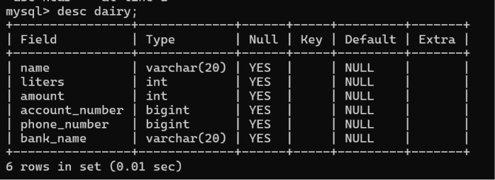

2.PRIMARY KEY
DESC dairy;
ALTER TABLE dairy
ADD PRIMARY KEY (account_number);

OUTPUT:

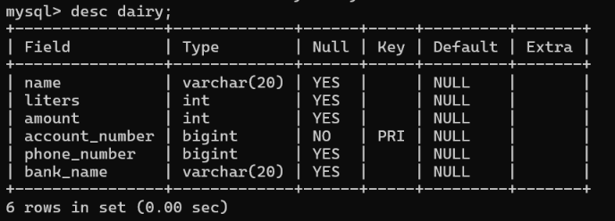

3.UNIQUE KEY
DESC dairy;
ALTER TABLE dairy
ADD UNIQUE (phone_ number)

OUTPUT:

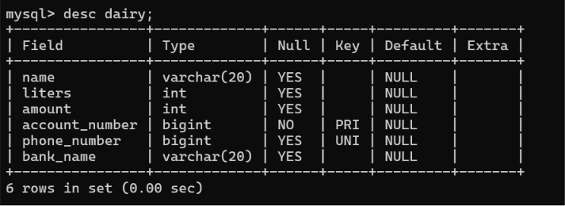

4.CHECK CONSTRAINT:
DESC dairy;
ALTER TABLE dairy
ADD CONSTRAINT chk_liters CHECK(liters>0),
ADD CONSTRAINT chk_amount CHECK(amount>=0);
OUTPUT:

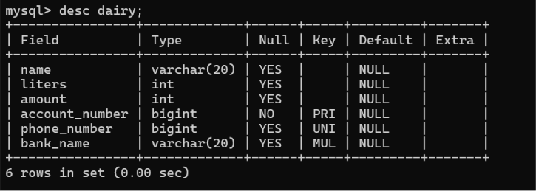

5.FOREIGN KEY CONSTRAINT:
ALTER TABLE dairy
-> ADD CONSTRAINT fk_bank
-> FOREIGN KEY (bank_name)
-> REFERENCES bank(bank_name);
OUTPUT:

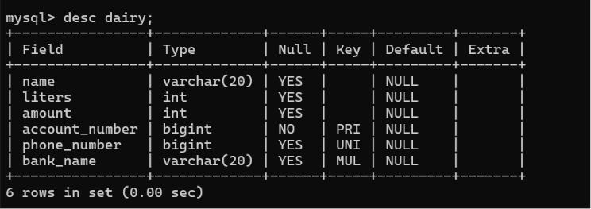

RESULT: DDL Commands with Primary, Foreign, Unique, Check constraints are updated and verified.

